[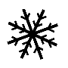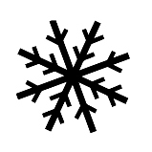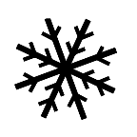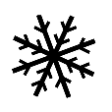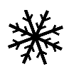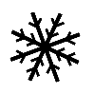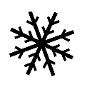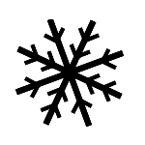](https://www.google.ca/url?sa=i&rct=j&q=&esrc=s&source=images&cd=&cad=rja&uact=8&ved=2ahUKEwiF_d2YgN7dAhUBheAKHVIBAuUQjRx6BAgBEAU&url=https://www.impressions-languedoc.eu/noel/401-flocon-neige.html&psig=AOvVaw2-fjuNwX-mS_OTmrsmupEF&ust=1538234482618081)[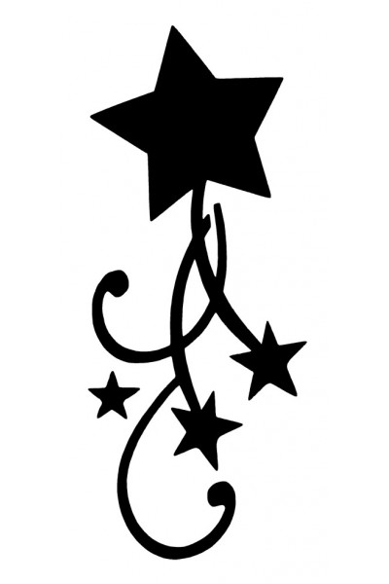](https://www.google.ca/url?sa=i&rct=j&q=&esrc=s&source=images&cd=&cad=rja&uact=8&ved=2ahUKEwi2h8j8-d3dAhUJh-AKHWltCBYQjRx6BAgBEAU&url=https://www.tatouage-paillettes.fr/theme-etoiles-soleil/181-pochoir-tattoo-fee-sur-lune.html&psig=AOvVaw0vJFr3UR19hp3m4mUh4SKD&ust=1538232322582465)[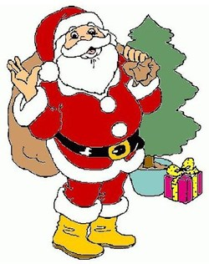](https://www.google.ca/url?sa=i&rct=j&q=&esrc=s&source=images&cd=&cad=rja&uact=8&ved=2ahUKEwiYqrik993dAhVJON8KHbvYD5QQjRx6BAgBEAU&url=https://www.nafeusemagazine.com/Modeles-de-Pere-Noel-a-dessiner-colorier-ou-decouper-_a552.html&psig=AOvVaw24VJ0-ua62gSpuYPo_e_NI&ust=1538232100197278) 05 décembre 2018

[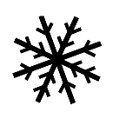](https://www.google.ca/url?sa=i&rct=j&q=&esrc=s&source=images&cd=&cad=rja&uact=8&ved=2ahUKEwiF_d2YgN7dAhUBheAKHVIBAuUQjRx6BAgBEAU&url=https://www.impressions-languedoc.eu/noel/401-flocon-neige.html&psig=AOvVaw2-fjuNwX-mS_OTmrsmupEF&ust=1538234482618081) Tous

[](https://www.google.ca/url?sa=i&rct=j&q=&esrc=s&source=images&cd=&cad=rja&uact=8&ved=2ahUKEwiF_d2YgN7dAhUBheAKHVIBAuUQjRx6BAgBEAU&url=https://www.impressions-languedoc.eu/noel/401-flocon-neige.html&psig=AOvVaw2-fjuNwX-mS_OTmrsmupEF&ust=1538234482618081) les enfants de

Saint-Claude

[](https://www.google.ca/url?sa=i&rct=j&q=&esrc=s&source=images&cd=&cad=rja&uact=8&ved=2ahUKEwiF_d2YgN7dAhUBheAKHVIBAuUQjRx6BAgBEAU&url=https://www.impressions-languedoc.eu/noel/401-flocon-neige.html&psig=AOvVaw2-fjuNwX-mS_OTmrsmupEF&ust=1538234482618081)

[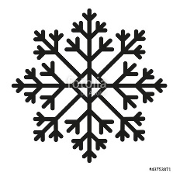](https://www.google.ca/url?sa=i&rct=j&q=&esrc=s&source=images&cd=&cad=rja&uact=8&ved=2ahUKEwiF_d2YgN7dAhUBheAKHVIBAuUQjRx6BAgBEAU&url=https://fr.fotolia.com/id/43753871&psig=AOvVaw2-fjuNwX-mS_OTmrsmupEF&ust=1538234482618081) Bonjour à tous les enfants!

[](https://www.google.ca/url?sa=i&rct=j&q=&esrc=s&source=images&cd=&cad=rja&uact=8&ved=2ahUKEwiF_d2YgN7dAhUBheAKHVIBAuUQjRx6BAgBEAU&url=https://www.impressions-languedoc.eu/noel/401-flocon-neige.html&psig=AOvVaw2-fjuNwX-mS_OTmrsmupEF&ust=1538234482618081)

[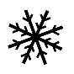](https://www.google.ca/url?sa=i&rct=j&q=&esrc=s&source=images&cd=&cad=rja&uact=8&ved=2ahUKEwiF_d2YgN7dAhUBheAKHVIBAuUQjRx6BAgBEAU&url=https://www.impressions-languedoc.eu/noel/401-flocon-neige.html&psig=AOvVaw2-fjuNwX-mS_OTmrsmupEF&ust=1538234482618081)[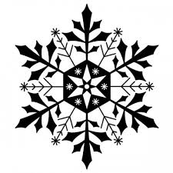](https://www.google.ca/url?sa=i&rct=j&q=&esrc=s&source=images&cd=&cad=rja&uact=8&ved=2ahUKEwi-9PGngN7dAhXiUN8KHdHCCIQQjRx6BAgBEAU&url=https://youdoit.fr/en/stamp-ink/1008-wooden-stamp-ice-flake.html&psig=AOvVaw2-fjuNwX-mS_OTmrsmupEF&ust=1538234482618081)[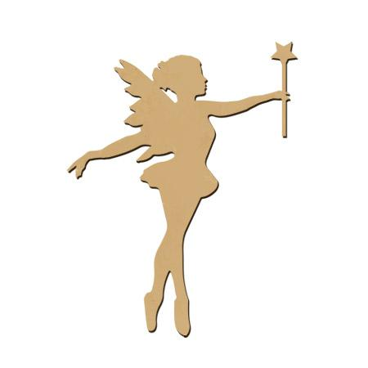](https://www.google.ca/url?sa=i&rct=j&q=&esrc=s&source=images&cd=&cad=rja&uact=8&ved=2ahUKEwjI6YCR-N3dAhUlVd8KHaZTC7cQjRx6BAgBEAU&url=https://www.scrapmalin.com/scrapbooking/p-sujet-en-bois-medium-ass-de-trois-fees-5-9-x-3-cm-la-fee-avec-etoile-4-6-4-7-cm-197220.html&psig=AOvVaw0vJFr3UR19hp3m4mUh4SKD&ust=1538232322582465)Cette année, le Père Noël ainsi que la Mère Noël m’ont confirmé qu’ils viendraient vous rendre

visite puisque vous avez été très sage.

**Quand : 16 décembre 2018**

**Où : Centre Aux Quatre Vents; 563, rang 7**

**Heure : à partir de 13 h**

[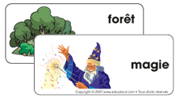](https://www.google.ca/url?sa=i&rct=j&q=&esrc=s&source=images&cd=&cad=rja&uact=8&ved=2ahUKEwj2xLa2-t3dAhVsmuAKHfg0CJMQjRx6BAgBEAU&url=https://www.educatout.com/activites/themes/les-fees.htm&psig=AOvVaw0vJFr3UR19hp3m4mUh4SKD&ust=1538232322582465)Nous t’invitons, toi et ta famille, à venir

célébrer l’arrivée de Noël lors de cette

journée magique!

[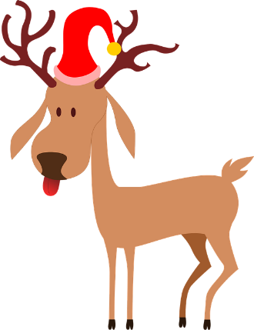](https://www.google.ca/url?sa=i&rct=j&q=&esrc=s&source=images&cd=&cad=rja&uact=8&ved=0ahUKEwiazsrsu53XAhVLnRQKHRaJCYIQjRwIBw&url=https://pixabay.com/fr/rennes-p%C3%A8re-no%C3%ABl-no%C3%ABl-bouchon-bois-307467/&psig=AOvVaw1hv7C58KxZJkPswvu9obqE&ust=1509628823242884)J’ai même entendu dire qu’il y aurait un spectacle de magie et comédie de la Ballounerie,

[](https://www.google.ca/url?sa=i&rct=j&q=&esrc=s&source=images&cd=&cad=rja&uact=8&ved=2ahUKEwi58ty-_t3dAhWCneAKHZazAKgQjRx6BAgBEAU&url=https://www.uniktattoo.com/pochoir-tatouage-temporaire-etoiles-6-unik-tattoo,fr,4,ET6.cfm&psig=AOvVaw2D2IrC-U5vo1veE2qk9puA&ust=1538234027679723)des maquilleuses, des ballons et plus encore!

[](https://www.google.ca/url?sa=i&rct=j&q=&esrc=s&source=images&cd=&cad=rja&uact=8&ved=2ahUKEwi58ty-_t3dAhWCneAKHZazAKgQjRx6BAgBEAU&url=https://www.uniktattoo.com/pochoir-tatouage-temporaire-etoiles-6-unik-tattoo,fr,4,ET6.cfm&psig=AOvVaw2D2IrC-U5vo1veE2qk9puA&ust=1538234027679723)**[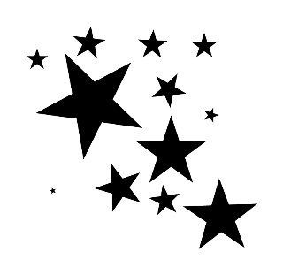](https://www.google.ca/url?sa=i&rct=j&q=&esrc=s&source=images&cd=&cad=rja&uact=8&ved=2ahUKEwi58ty-_t3dAhWCneAKHZazAKgQjRx6BAgBEAU&url=https://www.uniktattoo.com/pochoir-tatouage-temporaire-etoiles-6-unik-tattoo,fr,4,ET6.cfm&psig=AOvVaw2D2IrC-U5vo1veE2qk9puA&ust=1538234027679723)**Le Père Noël m’a dit qu’il est très heureux de venir vous rencontrer et il espère vous voir en grand nombre!

[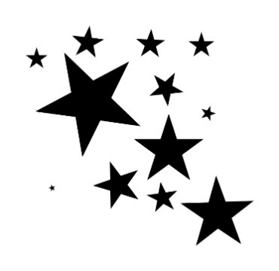](https://www.google.ca/url?sa=i&rct=j&q=&esrc=s&source=images&cd=&cad=rja&uact=8&ved=2ahUKEwi58ty-_t3dAhWCneAKHZazAKgQjRx6BAgBEAU&url=https://www.uniktattoo.com/pochoir-tatouage-temporaire-etoiles-6-unik-tattoo,fr,4,ET6.cfm&psig=AOvVaw2D2IrC-U5vo1veE2qk9puA&ust=1538234027679723)**[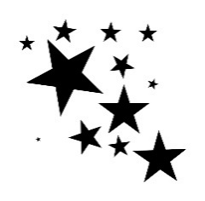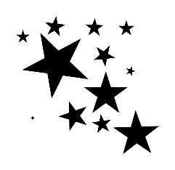](https://www.google.ca/url?sa=i&rct=j&q=&esrc=s&source=images&cd=&cad=rja&uact=8&ved=2ahUKEwi58ty-_t3dAhWCneAKHZazAKgQjRx6BAgBEAU&url=https://www.uniktattoo.com/pochoir-tatouage-temporaire-etoiles-6-unik-tattoo,fr,4,ET6.cfm&psig=AOvVaw2D2IrC-U5vo1veE2qk9puA&ust=1538234027679723)**[](https://www.google.ca/url?sa=i&rct=j&q=&esrc=s&source=images&cd=&cad=rja&uact=8&ved=2ahUKEwi58ty-_t3dAhWCneAKHZazAKgQjRx6BAgBEAU&url=https://www.uniktattoo.com/pochoir-tatouage-temporaire-etoiles-6-unik-tattoo,fr,4,ET6.cfm&psig=AOvVaw2D2IrC-U5vo1veE2qk9puA&ust=1538234027679723)**[](https://www.google.ca/url?sa=i&rct=j&q=&esrc=s&source=images&cd=&cad=rja&uact=8&ved=2ahUKEwi58ty-_t3dAhWCneAKHZazAKgQjRx6BAgBEAU&url=https://www.uniktattoo.com/pochoir-tatouage-temporaire-etoiles-6-unik-tattoo,fr,4,ET6.cfm&psig=AOvVaw2D2IrC-U5vo1veE2qk9puA&ust=1538234027679723)La Fée des Étoiles**

**[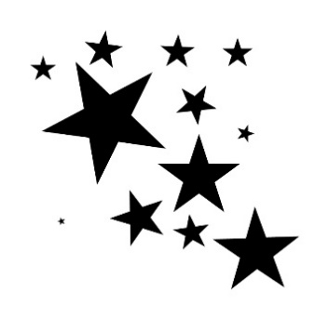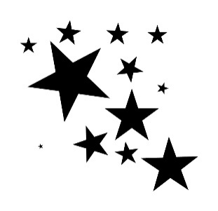](https://www.google.ca/url?sa=i&rct=j&q=&esrc=s&source=images&cd=&cad=rja&uact=8&ved=2ahUKEwi58ty-_t3dAhWCneAKHZazAKgQjRx6BAgBEAU&url=https://www.uniktattoo.com/pochoir-tatouage-temporaire-etoiles-6-unik-tattoo,fr,4,ET6.cfm&psig=AOvVaw2D2IrC-U5vo1veE2qk9puA&ust=1538234027679723)**

**[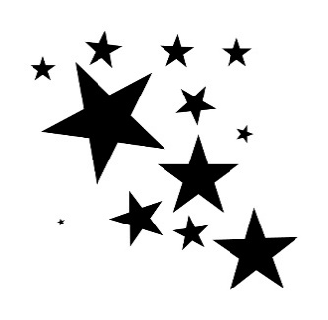](https://www.google.ca/url?sa=i&rct=j&q=&esrc=s&source=images&cd=&cad=rja&uact=8&ved=2ahUKEwi58ty-_t3dAhWCneAKHZazAKgQjRx6BAgBEAU&url=https://www.uniktattoo.com/pochoir-tatouage-temporaire-etoiles-6-unik-tattoo,fr,4,ET6.cfm&psig=AOvVaw2D2IrC-U5vo1veE2qk9puA&ust=1538234027679723)**